**HYPERTEXT MARKUP LANGUAGE**

**Headings**

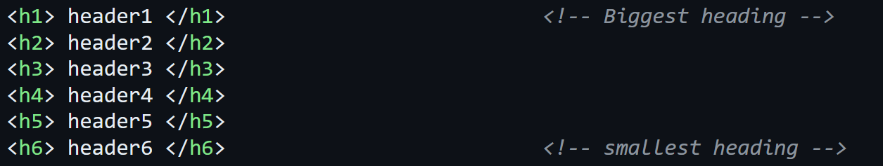

**Compulsory First Line**



* **'html'** is written for modern **HTML 5** documents.
* **Not** writing it may cause consistencies in ***quirk mode***.
* **Quirk mode:** Older HTML modes.

**Tab Bar Title**



**Paragraphs**



**Hyperlinks**



**Adding Images**



**Basic HTML Structure**

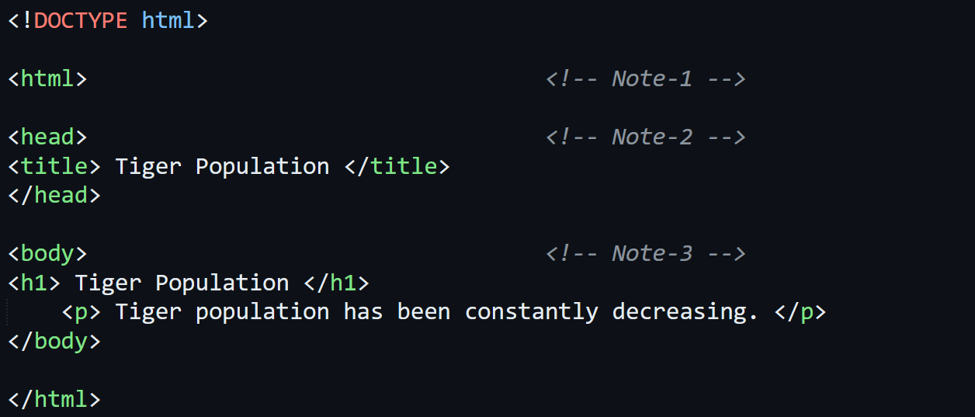

* **First line** must be **<DOCTYPE html>**.
* **Note #1** – Everything other than **<DOCTYPE html>** must be between **<html>** tags.
* **Note #2** – Elements which are **not** on the webpage must be between **<head>** tags.
* **Note #3** – Elements which are on webpage & **directly visible** to users, must be between **<body>** tags.
* **Not** using these compulsory tags **may raise problems** while processing a valid **HTML** document.

**Lists**

Unordered list:-

* Used where order **doesn’t** matter.
* Outputs are **bullet points**.

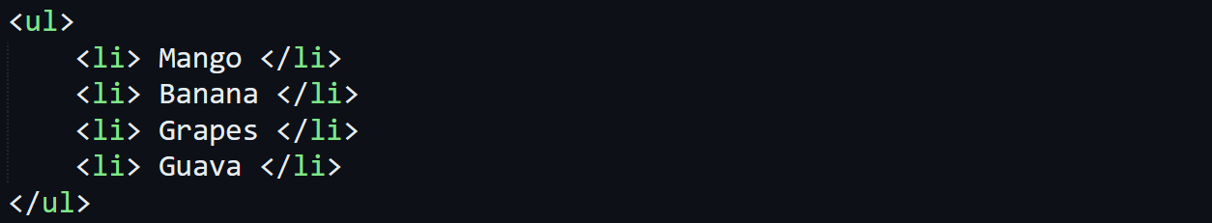

* **<li>** stands for **list item**.

Ordered list:-

* Outputs are **serial numbers**.

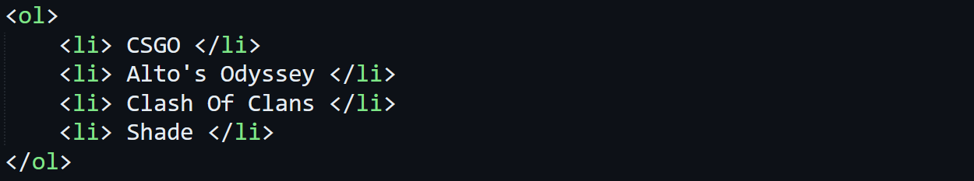

**Tables**

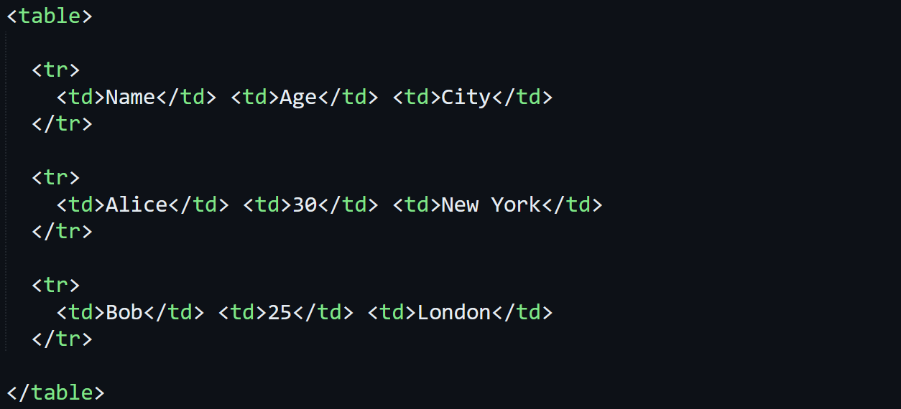

* **<tr>** stands for **table row**.
* **<th>** stands for **table header**.
* **<td>** stands for **table data cell**.

**Division**

* Used to **divide** various **sections** of an **HTML** **body**.
* **Doesn’t** actually impact the code but provides a clear structure.

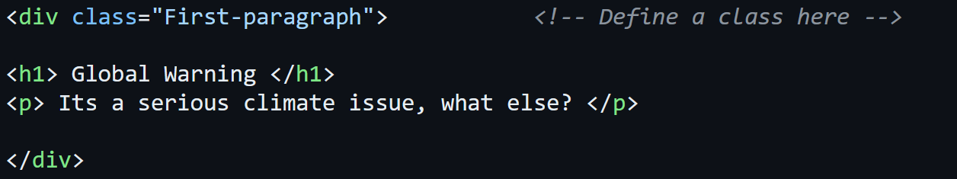

**Forms**

Text type forms:-

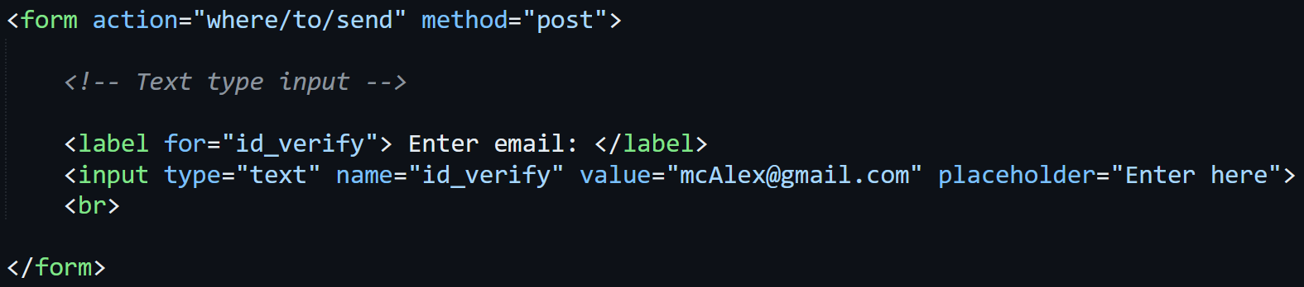

* In form, action tells **where** to send the **input data**.
* And method as **"post"** means to **send data** to the **server**, while "**get"** means to **retrieve it** instead.
* Text between **<label>** tags is **what is** displayed on webpage.
* In **<input>**, **type** tells **what kind of input** it is.
* While **value** places the **default value** & **placeholder** **hints** the user for input.
* Another parameter called **id** can be used in **<input>** to uniquely identify each element.
* **<br>** is break line/ **newline**.

Password type:-

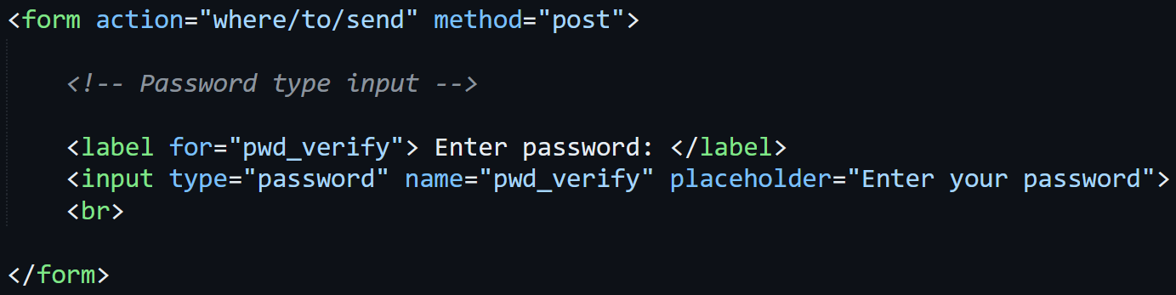

* Notice the type being **"password"**.

Radio button type:-

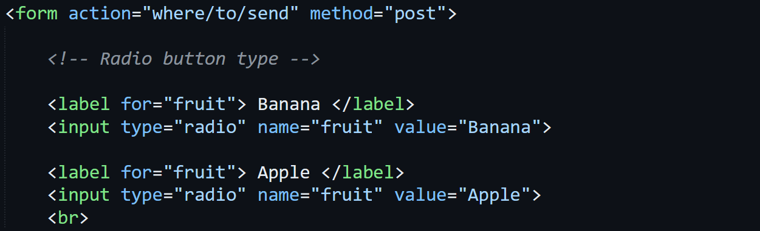

* Using **same** **for** & **name** in options/labels means **only one** of the given options can be selected.
* Just like in code above, either of **Banana** or **Apple** can be selected.

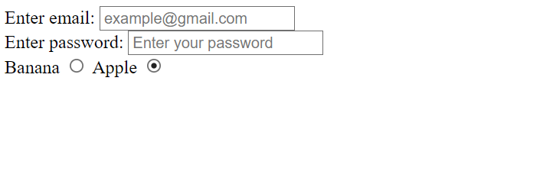

Button:-

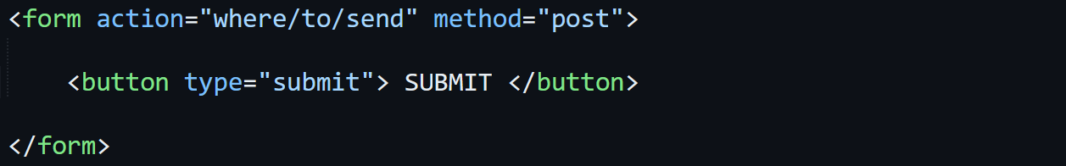

Text area:-



* Having **space** between the **opening** & **closing** tags of **<textarea>** may **not** show the **placeholder** on webpage.

**Header & Footer**

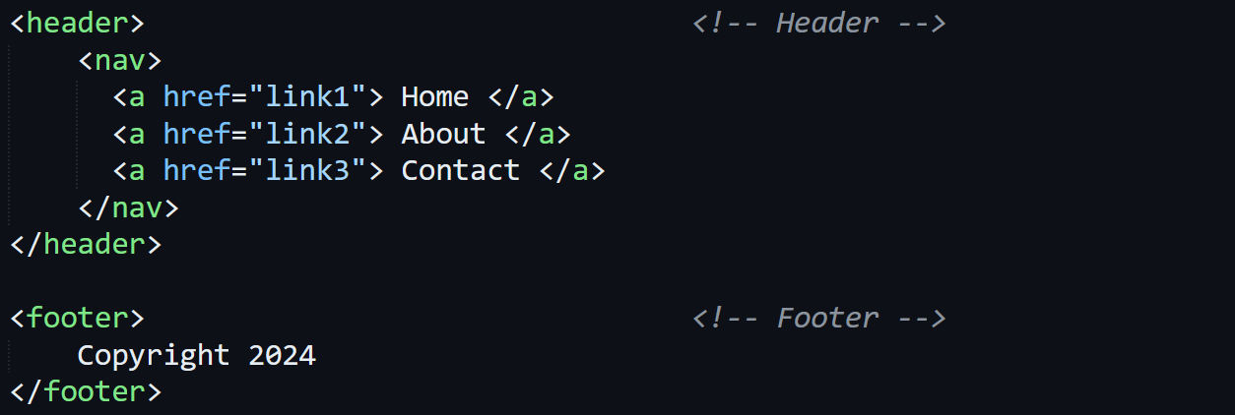

* **<nav>** tags are used to **group links together**.

**Grouping**

* **<section>** & **<aside>** are used the same way **<div>** does.
* Whereas **<article>** is used inside **<section>** for **sub-grouping**.
* And also **<article>** is a simple tag **without** any parameter.